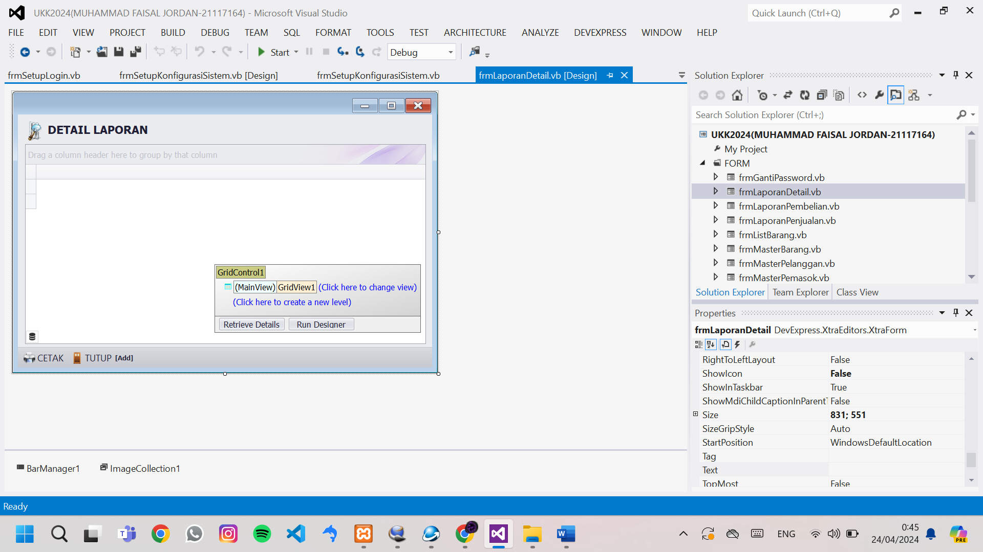

Public Class frmLaporanDetail

Dim Tampung As New DataTable

Public NilaiKiriman As Integer

Public ID As Integer

Sub TampilTable()

Select Case NilaiKiriman

Case 1

'untuk detail pembelian

Tampung = EksekusiSQL("select pembelian_detil.ID_BARANG,NAMA_BARANG,SATUAN,HARGA_SATUAN,JUMLAH,TOTAL_HARGA from pembelian_detil,barang where pembelian_detil.ID_BARANG=barang.ID_BARANG and ID_PEMBELIAN='" & ID & "'")

GridControl1.DataSource = Tampung

GridView1.Columns("HARGA_SATUAN").DisplayFormat.FormatType = DevExpress.Utils.FormatType.Numeric

GridView1.Columns("HARGA_SATUAN").DisplayFormat.FormatString = "c0"

GridView1.Columns("JUMLAH").DisplayFormat.FormatType = DevExpress.Utils.FormatType.Numeric

GridView1.Columns("JUMLAH").DisplayFormat.FormatString = "n0"

GridView1.Columns("TOTAL_HARGA").DisplayFormat.FormatType = DevExpress.Utils.FormatType.Numeric

GridView1.Columns("TOTAL_HARGA").DisplayFormat.FormatString = "c0"

GridView1.Columns("TOTAL_HARGA").SummaryItem.SetSummary(DevExpress.Data.SummaryItemType.Sum, "{0:c0}")

GridView1.BestFitColumns()

Case 2

'untuk ditail penjualan

Tampung = EksekusiSQL("select penjualan_detil.ID_BARANG,NAMA_BARANG,SATUAN,HARGA_SATUAN,JUMLAH,TOTAL_HARGA from penjualan_detil,barang where penjualan_detil.ID_BARANG=barang.ID_BARANG and ID_PENJUALAN='" & ID & "'")

GridControl1.DataSource = Tampung

GridView1.Columns("HARGA_SATUAN").DisplayFormat.FormatType = DevExpress.Utils.FormatType.Numeric

GridView1.Columns("HARGA_SATUAN").DisplayFormat.FormatString = "c0"

GridView1.Columns("JUMLAH").DisplayFormat.FormatType = DevExpress.Utils.FormatType.Numeric

GridView1.Columns("JUMLAH").DisplayFormat.FormatString = "n0"

GridView1.Columns("TOTAL_HARGA").DisplayFormat.FormatType = DevExpress.Utils.FormatType.Numeric

GridView1.Columns("TOTAL_HARGA").DisplayFormat.FormatString = "c0"

GridView1.Columns("TOTAL_HARGA").SummaryItem.SetSummary(DevExpress.Data.SummaryItemType.Sum, "{0:c0}")

GridView1.BestFitColumns()

End Select

End Sub

Sub CetakData()

Select Case NilaiKiriman

Case 1

'laporan cetak detil pembelian

GridView1.OptionsPrint.PrintFilterInfo = True

GridView1.OptionsPrint.RtfReportHeader = "DETAIL LAPORAN PEMBELIAN" & vbCrLf & "NOMOR TRANSAKSI" & ID & vbCrLf

TTD(GridView1)

ExecuteGridControlPreview(GridControl1, GridControl1.LookAndFeel, True, Printing.PaperKind.A4, 15, 15, 15, 15)

Case 2

'laporan cetak detil penjualan

GridView1.OptionsPrint.PrintFilterInfo = True

GridView1.OptionsPrint.RtfReportHeader = "DETAIL LAPORAN PENJUALAN" & vbCrLf & "NOMOR TRANSAKSI" & ID & vbCrLf

TTD(GridView1)

ExecuteGridControlPreview(GridControl1, GridControl1.LookAndFeel, True, Printing.PaperKind.A4, 15, 15, 15, 15)

End Select

End Sub

Sub Tutup()

Me.Close()

End Sub

Private Sub frmLaporanDetail_KeyDown(sender As Object, e As KeyEventArgs) Handles Me.KeyDown

Select Case e.KeyCode

Case e.Control And Keys.P

CetakData()

Case Keys.Escape

Tutup()

End Select

End Sub

Private Sub frmLaporanDetail_Load(sender As Object, e As EventArgs) Handles MyBase.Load

Me.KeyPreview = True

GridView1.OptionsView.ShowFooter = True 'aktifkan report footer

TampilTable()

End Sub

Private Sub BarButtonItem2_ItemClick(sender As Object, e As DevExpress.XtraBars.ItemClickEventArgs) Handles BarButtonItem2.ItemClick

CetakData()

End Sub

Private Sub BarButtonItem7_ItemClick(sender As Object, e As DevExpress.XtraBars.ItemClickEventArgs) Handles BarButtonItem7.ItemClick

Tutup()

End Sub

End Class